SIMATS ENGINEERING (SAVEETHA SCHOOL OF ENGINEERING)
Department of Computer Science and Engineering

CO2 ASSESSMENT TOOL 1 – Scenario-Based Requirement Analysis

Course Code: | CSA1013 | Course Title: | Software Engineering
CO Assessed: | CO2 | Assessment: | Assessment Tool 2 – Scenario-Based Requirement Analysis
Weightage: | 20% | Total Marks: | 25
CO2 Statement: | Perform detailed requirements analysis, design scalable architectures, and prioritize features with a focus on cross-disciplinary skills
Student Name: | Bheeshma L | Reg. No.: | 192511332
Date: | 03.08.2026 | Duration: | 60 minutes

Code of Conduct
I Bheeshma L / 192511332 (Name / Reg No) certify that this submission is my original work and that I have adhered to the guidelines specified for this assessment. I understand that any violation of academic integrity rules will result in disciplinary action.
Signature of the Student:

Rubrics for Calculation
Criteria | Excellent (4 Marks) | Good (3 Marks) | Satisfactory (2 Marks) | Needs  Improvement (1 Mark)
Scenario Understanding and Problem Analysis | Demonstrates thorough understanding of the scenario, stakeholders, objectives, and  business context with clear analysis. | Demonstrates good understanding with minor omissions. | Basic understanding with limited analysis. | Poor understanding; major aspects missing or incorrect.
Functional and Non-Functiona l Requirement Identification | Clearly identifies comprehensive, accurate, and well-classified functional and non-functional requirements. | Identifies most  requirements with minor classification errors. | Identifies only basic requirements; several omissions. | Requirements are incomplete, inaccurate, or poorly classified.
Actor Identification and Use Case Modeling | Correctly identifies all relevant actors and  use cases; use case diagram is complete, accurate, and follows UML standards. | Most actors and use cases  identified; diagram has minor errors. | Limited  actors/use cases identified; diagram partially correct. | Actors/use cases missing or incorrect; diagram absent or inaccurate.
Software  Requirement Specification | SRS is  well-structured, complete, professionally | SRS is organized with minor missing sections or formatting issues. | SRS includes only essential sections with limited detail. | SRS is incomplete, poorly organized, or

(SRS)  Documentation | organized, and  includes all required sections. |  |  | lacks essential components.
Assumptions, Constraints, and  Requirement Validation | Clearly identifies  realistic assumptions and constraints;  validates requirements for completeness, consistency, and ambiguity with  appropriate justification. | Identifies most assumptions and constraints; validation is adequate. | Limited assumptions/con straints; validation is superficial. | Assumptions, constraints, and validation are missing or incorrect.

Table of Contents
1. Introduction
2. Scope of the System
3. Functional Requirements
4. Non-Functional Requirements
5. Actors and Use Cases
6. Use Case Descriptions
7. Data Requirements
8. External Interface Requirements
9. System Features
10. Assumptions and Constraints
11. Validation of Requirement Completeness and Consistency
12. Conclusion

1. Introduction

1.1 Purpose
This Software Requirement Specification (SRS) document presents a detailed, scenario-based requirement analysis for AgriSmart, a precision-agriculture and farm-management platform. The purpose of this document is to define the functional and non-functional requirements, actors and use cases, system features, data and interface requirements, assumptions, constraints, and validation checks needed to design a scalable, reliable, and cross-disciplinary software solution that supports modern farm operations.

1.2 Business Domain
The business domain is Smart Agriculture / AgriTech, an area that combines software engineering with agronomy, environmental science, IoT/embedded systems, data science, and supply-chain logistics. The domain is inherently cross-disciplinary: effective requirement analysis requires understanding of crop science and farm operations alongside standard software architecture concerns such as scalability, integration, and data security.

1.3 Problem Description
Smallholder and mid-size farms typically rely on manual observation, traditional irrigation schedules, and informal knowledge-sharing to manage crops. This leads to inefficient water and fertilizer usage, delayed detection of pest or disease outbreaks, unpredictable yields, poor inventory and labour coordination, and limited market access for selling produce at fair prices. Existing farm-management tools are often siloed — separate apps for irrigation, weather, and marketplace access — resulting in fragmented data and poor decision-making.
AgriSmart addresses this by unifying IoT-based field monitoring, AI-driven crop advisory, task and inventory management, and a direct-to-buyer marketplace into a single scalable platform, enabling farmers and stakeholders to make faster, data-driven decisions.

1.4 Stakeholders
Stakeholder | Role / Interest in the System
Farmer / Farm Owner | Primary user; monitors fields, manages irrigation, sells produce.
Farm Supervisor / Labourer | Executes and reports on day-to-day field tasks assigned via the app.
Agronomist / Agricultural Advisor | Reviews sensor and imagery data to provide crop health advisory.
Buyer / Distributor | Purchases produce listed on the marketplace module.
System Administrator | Manages user accounts, system configuration, and platform health.
Third-Party Service Providers | Weather API and payment gateway providers integrated with the platform.
Investors / Management (SIMATS context: Evaluators) | Interested in scalability, ROI, and adoption of the platform.

1.5 System Objectives
- Provide real-time monitoring of soil moisture, temperature, humidity, and crop health using IoT sensors.
- Optimize irrigation and resource usage through automated, data-driven scheduling.
- Enable early detection of pest and disease outbreaks using image-based AI diagnostics.
- Support task assignment and tracking between farm owners and field labour.
- Offer a direct marketplace connecting farmers with buyers and distributors.
- Ensure the platform is scalable to support multiple farms, regions, and crop types.
- Maintain data security and reliability for financial transactions and farm records.

2. Scope of the System
AgriSmart is a cloud-hosted, mobile-and-web-accessible platform intended for use by individual farmers, farm supervisory staff, agronomists, and produce buyers. The scope of the initial release (Version 1.0) includes:
- Field/farm registration and profile management.
- Real-time IoT sensor data ingestion and dashboard visualization.
- Automated irrigation scheduling and alerting.
- AI-based crop recommendation and pest/disease diagnosis from images.
- Task assignment and tracking for field labour.
- Inventory and equipment management.
- Yield prediction reporting.
- A produce marketplace with order placement and payment processing.
- Role-based user authentication and administration.
Out of scope for this release: autonomous farm machinery/robotics control, drone flight operations, and government subsidy/compliance filing integrations. These may be considered in future versions.

3. Functional Requirements
ID | Functional Requirement
FR-01 | The system shall allow farmers to register and manage one or more farm/field profiles including location, crop type, and area.
FR-02 | The system shall ingest and display real-time data from IoT sensors (soil moisture, temperature, humidity, pH).
FR-03 | The system shall generate automated alerts when sensor readings cross configurable safe thresholds.
FR-04 | The system shall allow farmers to create, view, and modify irrigation schedules, with an option for automated scheduling based on sensor and weather data.
FR-05 | The system shall fetch and display short-term and seasonal weather forecasts from an external weather service.
FR-06 | The system shall provide AI-based crop recommendations based on soil data, location, and historical yield.
FR-07 | The system shall allow users to upload plant/leaf images for AI-based pest and disease diagnosis and return a probable diagnosis with suggested remedies.
FR-08 | The system shall allow farm supervisors to assign field tasks to labourers and track completion status.
FR-09 | The system shall allow tracking of inventory items (seeds, fertilizer, equipment) including quantity and reorder alerts.
FR-10 | The system shall generate a predictive yield report based on historical and current-season data.
FR-11 | The system shall allow farmers to list produce for sale on an integrated marketplace, including price, quantity, and quality grade.
FR-12 | The system shall allow buyers/distributors to search, place, and track orders for listed produce.
FR-13 | The system shall process payments securely through an integrated payment gateway and generate transaction receipts.
FR-14 | The system shall support role-based authentication (Farmer, Supervisor, Agronomist, Buyer, Administrator) with secure login.
FR-15 | The system shall allow administrators to manage user accounts, roles, and system-wide configuration settings.
FR-16 | The system shall maintain an audit log of key transactions and user actions for traceability.

4. Non-Functional Requirements
Category | Requirement Description
Performance | The system shall process and display incoming IoT sensor data within 5 seconds of receipt, and shall support at least 10,000 concurrent sensor data streams at peak load.
Security | All user credentials shall be stored using industry-standard hashing (e.g., bcrypt), and all payment and personal data shall be encrypted in transit (TLS 1.2+) and at rest.
Reliability | The system shall maintain a Mean Time Between Failures (MTBF) suitable for 24x7 farm operations, with automated failover for the sensor-ingestion service.
Usability | The mobile and web interfaces shall be usable by farmers with limited digital literacy, supporting multilingual UI and offline-first data entry with later sync.
Scalability | The architecture shall support horizontal scaling to onboard new farms/regions without downtime, using a microservices-based design and cloud auto-scaling.
Maintainability | The system shall be built using modular, well-documented microservices to allow independent updates to modules such as the marketplace or AI diagnostics engine.
Availability | The core monitoring and alerting services shall achieve at least 99.5% uptime, given the safety-critical nature of irrigation and pest alerts.
Interoperability | The system shall expose REST/GraphQL APIs to integrate with third-party weather services, payment gateways, and government agricultural data portals.
Data Integrity | Sensor and transactional data shall be validated and timestamped at ingestion, with periodic automated backups and checksums to detect corruption.

5. Actors and Use Cases

5.1 Identified Actors
Actor | Type | Description
Farmer / Farm Owner | Primary | Registers farms, monitors field data, schedules irrigation, views recommendations, lists produce, manages account.
Farm Supervisor / Labourer | Primary | Executes assigned tasks, updates task status, manages on-ground inventory usage.
Agronomist / Agricultural Advisor | Primary | Reviews diagnostic and sensor data, provides crop advisory, validates AI recommendations.
Buyer / Distributor | Primary | Searches marketplace listings, places orders, makes payments, tracks delivery.
System Administrator | Secondary | Manages users, roles, and system configuration; monitors platform health and audit logs.
IoT Sensor Network | Secondary (external) | Automatically streams soil, temperature, humidity, and pH data into the system.
Weather Service API | Secondary (external) | Supplies external forecast data used for irrigation and advisory decisions.
Payment Gateway | Secondary (external) | Processes marketplace payments and returns transaction confirmations.

5.2 Major Use Cases by Actor
- Farmer: Register Farm/Field Profile, Monitor Real-Time Soil & Crop Data, Schedule Smart Irrigation, View AI Crop Recommendations, List Produce on Marketplace, Authenticate/Manage Account.
- Farm Supervisor: Assign Field Tasks, Track Task Completion, Manage Inventory & Equipment.
- Agronomist/Advisor: Provide Crop Advisory, Diagnose Pest/Disease (Image AI), Generate Yield Prediction Report, View AI Crop Recommendations.
- Buyer/Distributor: List... (view) Marketplace, Place/Track Order, Process Payment.
- System Administrator: Manage Users & System Config, View Audit & Analytics Logs, Authenticate/Manage Account.
- External Actors: Fetch Weather Forecast (Weather API), Receive Automated Alerts (IoT Sensor Network).

5.3 Use Case Diagram
The diagram below illustrates the interactions between the identified primary and secondary actors and the core use cases of the AgriSmart system, following standard UML use-case notation (actors as stick figures, use cases as ovals, associations as connecting lines, all bounded within the system boundary).
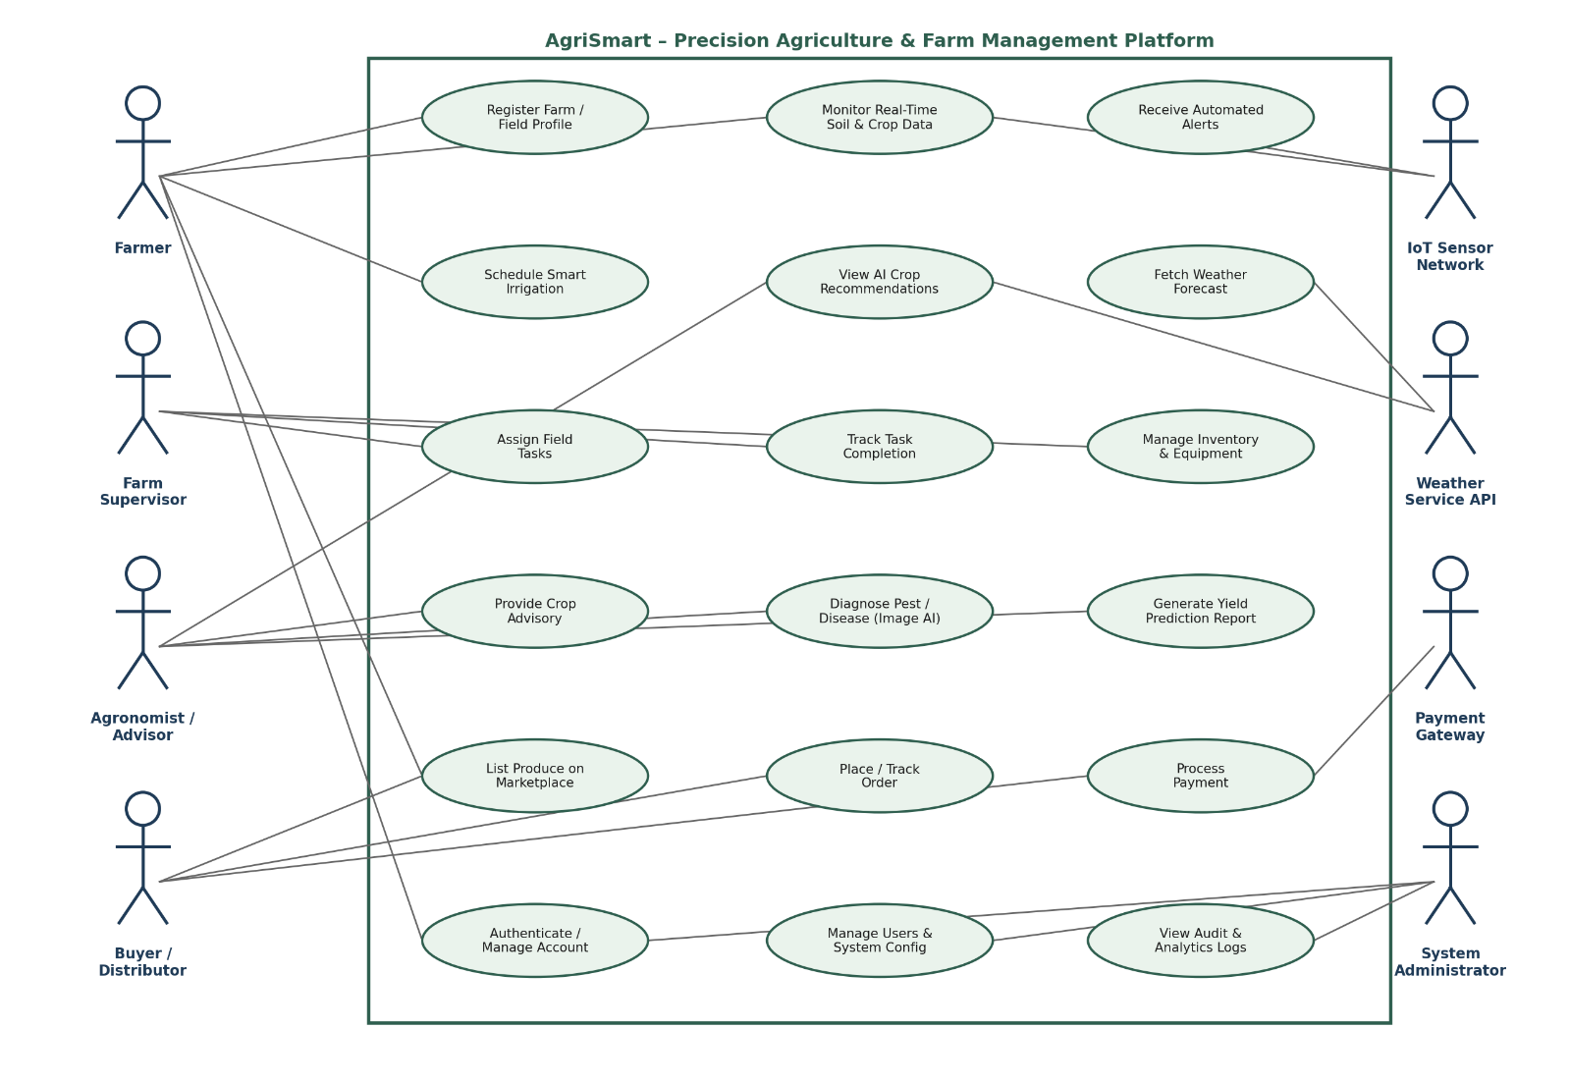

6. Use Case Descriptions

6.1 UC-01: Schedule Smart Irrigation
Use Case ID | UC-01
Use Case Name | Schedule Smart Irrigation
Actors | Farmer
Precondition | Farmer is logged in and the field profile has at least one active soil-moisture sensor.
Main Flow | 1. Farmer navigates to the Irrigation module.  2. System displays current soil-moisture and weather-forecast data for the selected field.  3. Farmer selects manual scheduling or enables automated mode.  4. System validates the schedule against safe thresholds and confirms.  5. System triggers irrigation actuators (or notifies farmer for manual systems) at scheduled times.
Postcondition | Irrigation schedule is saved and applied; farmer receives confirmation and subsequent status alerts.
Exception Flow | If sensor data is unavailable, the system falls back to a default rule-based schedule and notifies the farmer of degraded accuracy.

6.2 UC-02: Diagnose Pest/Disease (Image AI)
Use Case ID | UC-02
Use Case Name | Diagnose Pest/Disease using Image AI
Actors | Farmer, Agronomist/Advisor
Precondition | Farmer has captured a clear image of the affected plant/leaf and has an active internet connection or queued offline upload.
Main Flow | 1. Farmer uploads plant/leaf image through the mobile app.  2. System runs the image through the AI diagnostic model.  3. System returns a probable diagnosis with a confidence score and suggested remedies.  4. Agronomist may review and annotate the AI result for confirmation.  5. System stores the diagnosis in the field's health history.
Postcondition | Diagnosis and recommended action are recorded and made visible to the farmer and agronomist.
Exception Flow | If the image quality is insufficient or confidence is below threshold, the system flags the case for manual agronomist review.

6.3 UC-03: Place and Track Order
Use Case ID | UC-03
Use Case Name | Place and Track Order
Actors | Buyer/Distributor, Payment Gateway
Precondition | Buyer is registered and authenticated; the desired produce listing is active and in stock.
Main Flow | 1. Buyer searches or browses marketplace listings.  2. Buyer selects a listing and specifies quantity.  3. System reserves the quantity and redirects to the Payment Gateway.  4. Payment Gateway confirms transaction to the system.  5. System generates an order confirmation and notifies the farmer and buyer, and enables order tracking.
Postcondition | Order is created, stock is updated, and both parties can track status through to delivery.
Exception Flow | If payment fails or times out, the reserved quantity is released back to available stock and the buyer is notified.

7. Data Requirements
The following core data entities must be captured, stored, and managed by the system, with appropriate relational or document-based schema design to support scalability across multiple farms and regions.
Data Entity | Key Attributes
Farm/Field Profile | Farm ID, owner, location (GPS), area, crop type, soil type.
Sensor Reading | Sensor ID, field ID, timestamp, soil moisture, temperature, humidity, pH.
Irrigation Schedule | Field ID, schedule type (manual/auto), start time, duration, status.
Diagnostic Record | Image reference, field ID, AI diagnosis, confidence score, agronomist review notes, timestamp.
Task | Task ID, assigned to, field ID, description, due date, status.
Inventory Item | Item ID, name, category, quantity on hand, reorder threshold.
Marketplace Listing | Listing ID, farmer ID, produce type, quantity, price, quality grade, status.
Order & Transaction | Order ID, buyer ID, listing ID, quantity, amount, payment status, timestamps.
User Account | User ID, name, role, contact details, hashed credentials, last login.

8. External Interface Requirements

8.1 User Interfaces
- Mobile application (Android/iOS) for farmers and supervisors, optimized for low-connectivity, offline-first use.
- Web-based dashboard for agronomists, buyers, and administrators with richer data-visualization and reporting.

8.2 Hardware Interfaces
- IoT soil/climate sensors communicating over LoRaWAN/Wi-Fi/GSM to an edge gateway or directly to the cloud.
- Optional integration with irrigation actuators/valves for automated watering.

8.3 Software / API Interfaces
- Weather Service API for forecast data (REST/JSON).
- Payment Gateway API for transaction processing (REST, PCI-DSS compliant).
- SMS/Push notification gateway for alerts to users with limited smartphone/app access.

8.4 Communication Interfaces
- HTTPS/TLS for all client-server communication.
- MQTT or CoAP for lightweight IoT sensor-to-cloud messaging.

9. System Features
Feature | Priority | Description
Real-Time Field Monitoring Dashboard | High | Central visualization of live sensor data, alerts, and field status across all registered farms.
Smart Irrigation Scheduler | High | Automated or manual irrigation planning driven by sensor and weather data.
AI Crop Advisory & Pest Diagnosis | High | Image-based diagnostics and recommendation engine for crop health and yield optimization.
Task & Inventory Management | Medium | Assignment, tracking, and reporting of field tasks and resource inventory.
Yield Prediction Reporting | Medium | Predictive analytics reports to support planning and financial decisions.
Marketplace & Order Management | High | Direct-to-buyer produce listing, ordering, and payment processing.
Role-Based Access & Administration | High | Secure authentication and system configuration management for all user roles.
Notifications & Alerts | High | Multi-channel (push/SMS) alerts for threshold breaches, task updates, and order status.

10. Assumptions and Constraints

10.1 Assumptions
- Farmers have access to at least a basic smartphone and intermittent internet connectivity for periodic data sync.
- IoT sensors are pre-installed and maintained by the farm or a third-party vendor; the software assumes valid, calibrated readings.
- Weather and payment gateway third-party services provide stable, documented APIs with reasonable uptime guarantees.
- Users have basic literacy in their local language sufficient to interact with a simplified mobile UI.
- Initial deployment targets a specific pilot region/crop type before scaling to other regions and crops.

10.2 Constraints
Type | Constraint
Technical | The system must operate reliably over low-bandwidth, intermittent rural network conditions and support offline data entry with later synchronization.
Operational | Field supervisors and agronomists must be trained on the platform; support must be available in local languages.
Economic | The solution must use cost-effective, low-power IoT hardware and cloud resources suitable for small and mid-size farm budgets.
Legal | The system must comply with data-protection regulations for personal and financial data, and with payment-industry (PCI-DSS) standards.
Time | The initial pilot release must be delivered within the academic/project timeline of one semester, limiting Version 1.0 scope as defined in Section 2.

11. Validation of Requirement Completeness and Consistency

11.1 Stakeholder Coverage Check
Each identified stakeholder (Section 1.4) is mapped to at least one functional requirement and use case: Farmers (FR-01, FR-02, FR-04, FR-06, FR-11), Supervisors (FR-08, FR-09), Agronomists (FR-06, FR-07), Buyers (FR-12, FR-13), and Administrators (FR-15, FR-16). No stakeholder is left without a corresponding capability, confirming completeness of stakeholder coverage.

11.2 Ambiguity, Redundancy, and Inconsistency Review
- Ambiguity: Vague terms such as 'fast' or 'user-friendly' have been replaced with measurable criteria in the Non-Functional Requirements (e.g., '5 seconds', '99.5% uptime') to remove subjectivity.
- Redundancy: FR-06 (crop recommendations) and FR-07 (pest/disease diagnosis) were reviewed to ensure they address distinct concerns (proactive advisory vs. reactive diagnosis) rather than duplicating one another.
- Inconsistency: The offline-first usability requirement (Section 4) was cross-checked against the real-time monitoring requirement (FR-02) and reconciled by specifying that offline mode applies to data entry, while monitoring assumes connectivity — avoiding a contradictory requirement.

11.3 Suggested Improvements
- Introduce a formal requirements traceability matrix (RTM) linking each FR/NFR to specific test cases before implementation.
- Conduct stakeholder walkthroughs (especially with farmers and agronomists) to validate that the AI advisory outputs align with real-world agronomic practices.
- Define explicit Service-Level Agreements (SLAs) with third-party weather and payment providers to strengthen the interoperability requirements.
- Add a data-retention and privacy policy section in a future revision to more precisely address legal constraints around farmer and buyer personal data.
- Prioritize FR-02, FR-04, and FR-07 for early-stage implementation, as they deliver the highest immediate value to the primary stakeholder (the farmer), consistent with the CO2 focus on feature prioritization.

12. Conclusion
This SRS document has analyzed the AgriSmart precision-agriculture scenario end-to-end: from business context and stakeholder identification, through functional and non-functional requirements, actor and use-case modeling, detailed use-case flows, data and interface requirements, system features with prioritization, and a structured validation of completeness and consistency. The resulting specification provides a scalable, cross-disciplinary foundation — spanning software engineering, IoT, data science, and agronomy — for the design and implementation of the AgriSmart platform.

